 | MINISTRY OF EDUCATION AND TRAINING

FPT UNIVERSITY

Capstone Project Document

English For Kid

Version 1.0

E4K Team
Group members | Truong Minh Tien - SE61076  Kieu Minh Tam - SE02832  Dang Van Tuan - SE02433  Nguyen Hai Long - 01417
Supervisor | Mr. Phan Duy Hung
Capstone project code | E4K

- Hanoi, September 2015 -
Table of Contents
Table of Contents 2
I. Introduction 1
1. Document Introduction 1
1.1 Purpose 1
1.2 Acronyms and Definitions 1
2. Abstract 1
3. Existing systems 1
3.1 Kids ABC letters 1
3.2 E-kidsongs 2
4. Idea 3
5. Proposal for the new system 3
5.1 Comparison between Android OS and iOS 4
5.1.1 Market share 4
5.1.2 Development 4
5.1.3 Conclusion 5
5.2 E4G project proposal 5
5.2.1 Overview 5
5.2.2 New feature 7
5.2.3 Limitations 7
5.2.4 Potential business risks 7
II. Software Project Management Plan 8
1. Problem Definition 8
1.2 Name of this Capstone Project 8
1.3 Problem Abstract 8
1.4 Project Overview 8
1.4.1 The existing systems & The Proposed System 8
1.4.2 Boundaries of the System 8
1.4.3 Development Environment 9
2. Project organization 9
2.1 Software Process Model 9
2.2 Roles and Responsibilities 11
2.3 Tools and Techniques 15
3. Project management plan 16
3.1 Tasks 16
3.2 Task Sheet: Assignments and Timetable 17
3.2.1 Work Breakdown Structure and Estimation 17
3.2.2 Meeting schedule 17
3.3 All Meeting Minutes 18
3.4 Communication Plan 18
3.4.1 Team project communication 18
3.4.2 Communication with supervisor 18
3.5 Coding Convention 19
3.5.1 Java coding convention 19
a. Formatting Conventions 19
i. Indent nested code. 19
ii. Break up long lines 21
iii. Include white space. 21
b. Use a single space to separate: 22
c. Use blank lines to separate: 22
d. Use a single space to separate: 23
e. Use blank lines to separate: 23
f. Naming Conventions 24
i. Package Names 24
ii. Type Names 24
iii. Class Names 25
iv. Interface Names 25
v. Method Names 26
vi. Variable Names 26
vii. Field Names 28
viii. Parameter Names 28
ix. Constant Names 29
g. Documentation Conventions 29
i. Comment Types 29
ii. Documentation Comments 31
iii. Comment style 32
iv. Comment content 38
3.5.2 Android coding style 39
a. Java Language rules 39
i. Don’t Ignore Exception 39
ii. Don’t Catch Generic Exception 41
iii. Don’t Use Finalizers 42
iv. Fully Qualify Imports 42
b. Java Library rules 42
c. Java Styles rules 43
i. Write Short Methods 43
ii. Define Fields in Standard Places 43
iii. Limit Variable Scope 43
iv. Follow Field Naming Conventions 44
v. Limit Line Length 44
vi. Log Sparingly 45

Record of Changes

Version | Date | Person | Content
v1.0 | 11/09/2015 | TienTM, TamKM, TuanDV, LongNH | Create new

I. Introduction

Document Introduction

Purpose
This document is created to provide overview of project. It will include the overview of some existing system, the ideal of our project, a brief description about our expected system.

Acronyms and Definitions

Acronym & Abbreviation | Definition
- E4K | - English for kid

Table 1: Definitions and Acronyms

Abstract

In today’s global world, the importance of English can not be denied and ignored since English is the most common language spoken everywhere. With the help of developing technology, English has been playing a major role in many sectors including medicine, engineering, and education. Because of the important of English, Many parents want to help their child or children to learn English but are not sure what they can do to help. Almost people let’s their child learning English at school but have low effectiveness because they study not only English but also another subjects at school. Others people choose foreign language Center but they have to pay a high price for this. About 5 years ago with the development of the Internet, people can learn English by a computer connect with the Internet. But it is rather expensive, and inconvenient because of big size. Besides, smart phone now become the popular device. So people can take advantage of technology to learn English more convenient. With simple app, kid can learn English every time and everywhere. No way to learning English better than playing some funny game with colorful. From this problems, our application will tends to
- Help consumers saving their money on foreign language Center.
- Child can study English by themself via interest games.
- It causes excitement for kids, make them feel interesting with learning English.
- It is an useful method of intellectual entertainment, help kids not only feel relax but also have new knowledge about English.

Existing systems

Kids ABC letters



Kids ABC Letters app for android is the English alphabet learning for young children.
Advantages:
- Very fun.
- This app invites preschoolers will hear and learn ABC alphabet in ways that can make them spellbound.
- Children will learn to spell letters and practicing drawing them
- Children will identify and search alphabetic letters in a passage that scene.
Disadvantages:
- Does not teach children about the phonetic like the alphabet used to

E-kidsongs


Learn vocabulary through English songs
Advantages:
- Very fun.
- Fast receptive.
- Free and offline
Disadvantages:
- This app is just a list of video.

Idea

E4K is an app help kids learning English. Our app will include all function listening, reading, writing. By tap on the screen, kids can learn English with fun and interest. We toward on give kid environment to play and learn English more attractive and interesting.

Proposal for the new system

From the given idea, the project is mainly target to the suppliers of groceries or suppliers with existing delivery system. As for the consumers, we want even people with average income able to use their phones to shop. Choosing the appropriate smartphones to work with will bring us a start with a larger pool of users which can bring back more possibility of success.
Vietnam Smartphone market now has plenty type of phones with different operating system. According to sale data, smartphones come with these two operating systems are the new trend

- iOS: exclusive for Apple products
- Android OS: has a wide range of phone currently using from various phone manufacturers (Samsung, HTC, Sony Ericsson...)

* This does not mean we only develop for one chosen OS. Application for the remaining OS will be developed in the future as we get users' feedback for the demo application.

Comparison between Android OS and iOS

Market share

According to data provided by IDC (International Data Corporation), in Q3 2011, Android has a market share of 67% of total smart phone in use in Vietnam, while iOS only has 39,3%. This can be easily explained because Android supports a wide range of phones, from the really cheap ones from China to the as expensive as iPhone of Apple.

Application download from appstore is also to Android's favor. Statistic from one of the largest application providers of Vietnam – appstore.vn – shows that Android application providing service after only 6 months in use grew to have more than 120,000 users. Compare to the 978,000 of iOS, it is only one ninth, but also according to their static, the growth of users of Android is more than 40% a month, which will surpass iOS in the middle of 2012.

From these points, we can see that Android is fast growing and becoming more and more popular with Vietnamese users.

Development

Android is developer friendly since it uses Java and XML which are more popular than Objective-C of Apple. Android can also be debugged and tested easily while Apple requires you to provide an account for testing applications.

Android support easier web communicate because it is Java based.

Android market is free to up, which mean developers can have their applications up in the market fast, opposite to Apple's appstore: applications will be checked to ensure there is no harm to the users.

Conclusion

For the current scope of the capstone project, we choose Android for the following reason:

Android provides a better environment for the current scope of this project: fast development environment, based on Java so there are many open source available for reference.

From the point of user, Android is now widely used and at the top place of the smart phone market. In Vietnam, although Android is quite new, but recent trend show that its market share is growing fast. Android phones are also have a wide range of price, so many users can afford buying one for our application, while iPhone are quite expensive and not everyone can buy. This means developing on Android will get back many benefits like having a large pool of users, which result in more feedback data.

E4G project proposal

In this new system, we will inherit the good points of the existing application and overcome their limitations.

Overview

The application meets the needs all the skills of reading, speaking, listening, writing, vocabulary. So we have mini game for each skill separately
- Listening
- Multi choice game
- There are 5 topic: animals, vehicles, fruit, objects in the house, color. (maybe more)
- Each topic has 10 questions, each question 30 seconds
- The each question to 4 image (random in the database about 50 times), after hearing from the corresponding new image selected (which allows playback buttons)
- Your selection will be audible to indicate right or wrong then switched to next question
- Done 10 questions will sum up the score.
- Learn new words through hearing
- There are 5 topic: fruits, tools, animals, vehicles, color. (maybe more)
- Choose one topic will be the image of that subject appeared in turn, click on the emitted sound and text, swipe to reveal another image.
- Get the things
- There are four scene: In the supermarket, on your desk, on the dining table, traffic
- Heard a request for what things and quantities.
- Speaking
- Standard Pronunciation
- Show out and pronounced the word correctly.
- App will display the text corresponding to the user's pronunciation to users compare and know they mispronounce or exactly
- If the correct pronunciation automatically switches to the next word.
- If mispronounce out the text of mispronounce it, and users can pronounce it correctly, or press next to move to the next word
- There are two modes is easy (words that are familiar) and hard (all English words means).
- Writing
- Games queue
- There are 2 modes one player or two players.
- Mode 1 players:
+ Screen that shows any one word
+ Players scored one word that begins with the last letter of the word given. (Eg given from TABLE -> players fill EMPTY is correct). Time for 1 from the 30 seconds
+ If the player is playing audio properly filled correctly and additional point, load the next and to play
+ If players answer incorrectly or out of time, the sound wrong and show current points
- Mode 2 players:
+ Similar to the 1 player but no part of the app itself from the 2 people will automatically think of words that fill appropriate rule queue
+ Who answered correctly that another person should think of the next word, the next person can not find a word in the 30 seconds or wrong word then end of the game. Show the players win.
- Character is missing
- For images and the characters of the image meaning but will be missing few characters (For example the images of a table and the table below form stating T A _ L E. Requires completion players missing characters
- If you filled out correctly pronounce properly and then moved to another image and add point, if selected incorrectly, the sound wrong and summary points out.
- It is possible to select the mode more hard, which is deleted lost 2-3 characters, easy to be deleted 1 characters.
- Number the word in order
- For image and the character meaning of that image but random order (Examples for table image and the image below is a table that shows A B T L E. From these suggestions, but the wrong order which requires players to fill right from TABLE).
- Vocabulary
- Multi choice
- There are five topic: objects in the house, animals, vehicles, fruit, color. (maybe more)
- Each topic has 10 questions, each question 30 seconds
- Show the first image and four answer A B C D is the vocabulary related to that picture.
- Choose the correct answer is vocabulary
- Your selection will be audible to indicate right or wrong, then switched to next question
- Done 10 question will sum up score.

New feature

- Kid have to learn all the skill
They learn standard pronunciation, listen native Enghlish
- Mini game will stimulate thinking ability and memory of children

* The capstone project may not have all the features of the completed system as listed above due to the lack of time and resources. For more information please read 1.4.2 – Boundaries of the system

Limitations

In the scope of the capstone project
- Support only Android (Another OS will be support in the future)
- Response to young children or the beginners get acquainted with the English

Potential business risks

- Database is big, difficult to prepare amounts of data
- Lacks of children participate in using the final application. This may be because of the thought of afraid to change.

II. Software Project Management Plan

Project organization

Software Process Model

The project is planned to be completed within 2.5 months with the team of 4 people. So each person must handle one or more function of the product, self-analyzing, define tasks and be able to work cross-functional.

In a short time, we are building and improving the product step by step. Hence we can track the defects at early stages. This avoids the downward flow of the defects. So we used iterative and incremental development in the process model used for developing this project
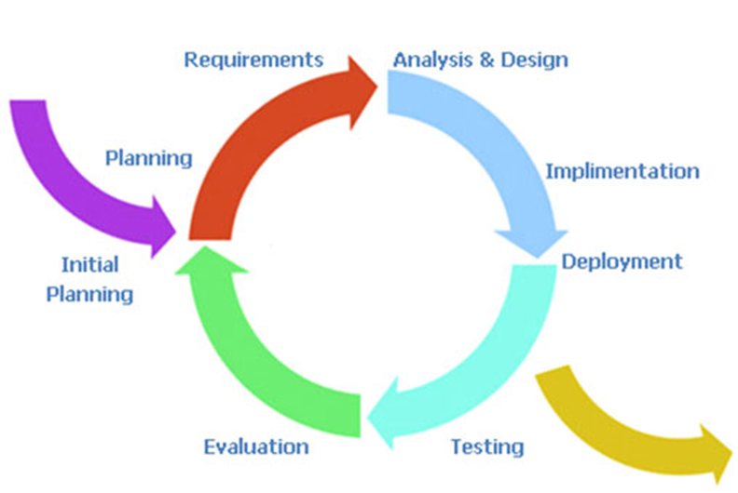
Figure 1: Iterative Model - Software Development Model

Roles and Responsibilities
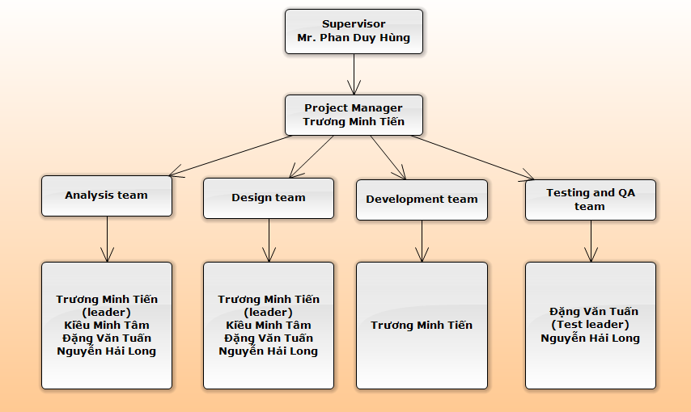

Here is the table that lists all roles and corresponding responsibilities in this project:

Role | Responsibilities
Project manager | - Managing and leading the project team.  - Responsible for driving the overall planning, management and completion of information technology projects and technical implementations.  - Leads projects by ensuring scheduling, delegating and monitoring project tasks, and reviewing project deliverables.  - Responsible for all project communication, including project status reporting and organizing project meetings and documents discussion and action items.  - Ensures all project documentation is complete, accurate, and current.  - Contact and work with the PS by reporting updates regarding the team’s progress status, obstacles, and concerns as well as eliciting advice.
Project Technical Leader | - Conduct research and recommend the most appropriate technologies, tools and methodologies that should be used for this project.  - Co-ordinate research efforts related to the project.  - Communicate information gathered or discovered from research to the team via email or during meetings.  - Support team members using the information discovered from research during the course of this project.
Quality assurance | - Control quality and managerial processes.  - Analyze and report test results. Evaluate test results as soon as possible after execution. Compare all test results with expected results and note that all defects are documented, regardless of how minor they appear or whether they will be corrected.  - Email weekly summaries of processes not being followed. If a process does not end in resolution, QA must raise the issues in the next team meeting.  - Write meeting minutes.
Developer | - Delegate coding tasks.  - Code, execute unit test and assure coding quality.  - Provide coding assistance for other members.  - Main developer must write the team’s coding guidelines and standards.
Risk manager | - Define risks as well as solutions at first stage of starting the project and manage, mitigate and monitor risks during this project’s lifetime.  - Conduct risk treatment strategies when risks occur in the attempt to reduce the impact on this project.
Tester | - Design and document test cases, execute test cases, record test case results, document and track defects, and perform test coverage analysis.  - In this capstone project, Testers will do Function test and System test:  - The test designer creates test cases that test at the level of distinct business events or functional process.  - The test designer creates test cases that test at the level of the system (Stress, Performance, Security, Recovery, etc.) or complete end-to-end business threads.
Configuration manager | - Responsible for providing the overall CM infrastructure and environment to the product development team.  - Ensure that directories and files in the SVN repository have correct structure and permissions and train team members to use SVN via email or during work sessions, meetings.  - Perform baseline procedures when requested by the PM and monitor the team’s adherence to formal change procedures on baseline documents.  - Perform daily and weekly backups of the team’s directory.
Document Maintainer | - Responsible for writing documents (gathering information, writing reports and project documentation). Has a responsibility for preparing a document for review, making review changes, updating the document version number.

In this project, we assign tasks as follows:
No | Person | Skill: Rate(max = 5) | Role
1 | Truong Minh Tien | Managing Skill: 4  Technical Knowledge: 4  Coding java Android app: 5  QA & Test:2 | Project Manager  Risk Manager  Project Technical Leader  Developer
2 | Kieu Minh Tam | Managing Skill: 4  Technical Knowledge: 4  Coding Java Android: 3  QA & Test:3 | Configuration Manager  Document Maintainer
3 | Dang Van Tuan | Managing Skill: 3  Technical Knowledge: 3  Coding Java Android: 3  QA & Test:5 | Document Maintainer  Quality Assurance  Tester
4 | Nguyen Hai Long | Managing Skill: 3  Technical Knowledge: 3  Coding Java Android: 3  QA & Test:5 | Document Maintainer  Quality Assurance  Tester
  - General Tasks:
    - Provide assistance to each member.
    - Team member has responsible for writing some components which he (she) has done in the report and must complete assigned tasks on time.
    - Maintain contact with the PM, TL and other to discuss the project’s progress, express issues and concerns for resolution.
    - Identify risks and communicate them with the risk manager and the team.

Tools and Techniques

E4K project uses the following tools and techniques:

- Tools for coding:
  - Eclipse with Android SDK
  - Text document
- Tools for documenting and merging codes, creating plan, updating status:
  - Tortoise SVN 1.6.15
  - Microsoft Office 2010
  - Microsoft Project 2010
  - Software Ideas Modeler
- Device for testing
  - Asus zenfone 5 (Android 4.4)
  - Asus zenfone 5 (Android 5.0)

Development environment

Coding software will be installed and run on:
- Windows 7
- Windows XP
Development, demo and testing environment:
- Android 4.4 kitkat
- Android 5.0
API sever:
- Google speech recognize API
Platform for coding program:
- Java SDK 1.6
Software for coding:
- Text document
- Eclipse with Android SDK
Hardware for development:
- Laptop Dell with Intel core i5 2.0, 8GB DDR3, 512GB HDD, Monitor with resolution 1366x768
- Asus zenfone 5

Project management plan

Tasks

Tasks | Description | Deliverables | Resource needed | Dependencies | Risks
Initial phase | Focus on studying and research information related to project objective, find existing solutions | ● Identify business objective, project objective   Learn about current systems: weak points, strong points   Find useful algorithms, libraries that are comfortable with project objective   Finish report No.1 | Document on Internet | NA | So many solutions for each part of our project. We must find what are the most solutions for our project
Project plan | Make clearly responsibility of each team member. Besides, we collection information to finish report No.2 | ● Collect requirements   Define scope   Create WBS(work breakdown structure)   Define activities   Estimate activities resource and durations   Develop schedule   Estimate cost, budget |  | Finish Initial phase | ● Lack of resource and document about the algorithms we use   Lack of information to choose which kind of equipment which is comfortable with programming
SRS | we work together to give out detail requirement of the system | ● A software requirement specification document:   External Interface requirements   System features   Software system attributes   Entity relationship diagram or data structures | NA | Finish Project plan phase | NA
Design System | Basing on SRS, we will create detail design for our system. | SDD document:   System architectural design   Component diagram   Detailed description of components   Sequence diagram   User Interface design | SRS document | Finish SRS phase | ● Lack of time
Implementation Testing | Developing system basing on  SDD document. Basing on SDD Design, SRS, we give out testing opinion and create test cases. | ● Release E4K project version 1.0 or beta version After finishing this phase, we can release a complete system and testing document such as:   Test Plan   Test cases   Checklists | SDD, SRS, URS  E4K project version 1.0 | Finish SDD phase  Finish implementation phase
Release project | Present our product with supervisors and create a guideline document. | ● PMS Project last version, document, slides presentation…   Final version of system and relative documents | ● E4K Project last version, document, slides presentation… | Finish testing phase | NA

Task Sheet: Assignments and Timetable

Work Breakdown Structure and Estimation

Refers to [E4K] ProjectManagement.mpp

Meeting schedule

Communication Type | Method / Tool | Date | Information | Participants / Responsible
Project Task Tracking
Daily Meeting | Face to Face, Skype | Daily(10 pm everyday) | Checking tasks progress | Project Team Members
Project Meeting
Kick-off Meeting | Face to face | 7-September-15 | Project introduction; Project plan; Estimate scope; | Supervisor, PM, Project Team Members
Project Progress Review Meetings | Face to face | Weekly (Saturday) | Communicate project status  Communicate and resolve any open issue, risks, and changes  Discuss any suggested improvement | PM, Project Team Members
Milestone Meetings | Face to face | Deliver report to supervisor | Project objective review, review report with supervisor | Supervisor ,PM, Project Team Members
Project Post-mortem Meeting | Face to face | Termination stage | Wrap-up  Evaluate project performance; Team performance; share experiences | Supervisor, PM, Project Team Members

All Meeting Minutes
(Please see the attached documents)

Communication Plan

Team project communication

Planning Phase: Team meeting daily at 10 p.m. everyday. Face to face meeting is the most effective way for team member to understand and clarify detailed requirement. Output of each meeting is a meeting minute to keep up important information.
Implement Phase: All members implement all task that PM and leader assigned. At 10 p.m. every day, team meeting daily and report to the whole team following template below

Communication with supervisor

Meets the supervisor at 8:30 a.m. Tuesday every week to get advices for issues, guide for writing document, correcting report and plan for the next week.
When having troubles in project, project manager collects ideas from members and send email or have a meeting with supervisor to get instructions or advices.
By the report, supervisor will tracking the progress of project

Coding Convention

Refer to:
- AndroidCodingConventions.pdf
- codeconventions-150003.pdf

http://www.idc.com/getdoc.jsp?pid=23571113&containerId=prVN23233011
http://www.vietnamandroid.com/tintuc/nguoi-dung-android-game.html

